Aaron Niecestro
BIST0650 Applied Longitudinal Analysis
December 7, 2021

Analysis of Autism Data using a Mixed Linear Model Approach

The dataset I used for this project was the Autism Dataset. This data was collected by researchers at the University of Michigan (Anderson et al. 2009) as part of a prospective longitudinal study of 155 children. The children were divided into two diagnostic groups (diagnosis) when they were 2 years old: Autism (autism), and Pervasive Developmental Disorder (pdd). The study was designed to collect information on each child at 5 visits at approximately 2, 3, 5, 9, and 13 years of age, although not all children were measured for each age because of drop-out and skipping visits (Appendix Table 2). There were only 41 out of 155 children that came to all 5 visits. The study objective for this project was to determine what variables have an influence on the Vineland Socialization Age Equivalent (VSAE), for children at two years of age and as they get older. The Vineland Socialization Age Equivalent is a measurement to assess a parent-reported measure of socialization using the Vineland Adaptive Behavior Interview survey form which considers and combines the interpersonal relationships, play/leisure time activities, and coping skills of children. Some of the other variables in the dataset included the visit number (obs), children’s age at their visit (age), length of time from the first visit (age2) (i.e., age2=1 at the obs=2), diagnostic category (diagnostic), language proficiency at age 2 (language), gender and race. Social development was assessed at each age using the Vineland Adaptive Behavior Interview survey form, a parent-reported measure of socialization. VSAE (Vineland Socialization Age Equivalent), was a combined score that included assessments of interpersonal relationships, play/leisure time activities, and coping skills. (Appendix Table 1)

Research Questions

To analyze and answer the study objective, I decided to create research questions to analyze, which are as follows:
- Do children with different language proficiency at age 2 have different levels of social development as they get older? If yes, is this statistically significant and if so, describe how this predicts VSAE?
- Do children diagnosed with autism at age 2 have different levels of social development as they get older than children diagnosed with pdd at age 2? If yes, is this statistically significant and if so, describe how this predicts VSAE?
- Do children whose race is categorized as white at age 2 have different levels of social development as they get older than children whose race is categorized as non-white at age 2? If yes, is this statistically significant and if so, describe how this predicts VSAE?
- Is gender predictive of vsae? Do children who are male at age 2 have different levels of social development as they get older than children who are female at age 2? If yes, is this statistically significant and if so, describe how this predicts VSAE?
- Are there other variables in this dataset predictive of vsae? If yes, is this statistically significant and if so, describe how this predicts VSAE?

Before making the models, I decided to make some summary statistics for the data and variables and build some visualizations so that I could gain more information into the Autism dataset. Through the tables I got to find out that the gender is very biased to males with approximately 87% of the children being male, which made me hypothesize that question 4 in the model analysis would probably not be true. It was also interesting to find out that the diagnosis (autism vs pdd) and race (white vs nonwhite) proportions and percentages were not close to being equal or the same. (Appendix Table 2) This showed me the demographics int the data are not equal so there will be some bias in my results. From the graphs I was able to conclude that the median socialization development score for children increases as a child gets older. (Appendix Table 7) It can also be seen that overall, there are more outliers and higher quartile in the graphs as the children get older, which might be caused by the amount of data collected at each of the five visits relatively decreasing. (Appendix Graph 1, 3, & 5) The sharpest rate of decline in children following up in their visits were from visit 2 (child’s age = 3) to visit 3 (child’s age=5). (Appendix 2, 4, & 6) Another thing is that one can see that the socialization development score (vsae) was steadily increasing until a child was approximately nine years old where the score jumped up a lot higher when a child was approximately thirteen years old. (Appendix Graph 7) I believe that the most shocking information I found from these summary statistics was that only 41 out of 155 children (26.45%) were able to make it to all five visits and the child with ID #60 was allowed to enter the study at 3 years of age, which was one visit higher than the baseline of the study.

Study Methods and Measures

I believe that the mixed linear effects models with random intercept and random slope was the best option to analyze the research questions I had for the Autism dataset. I had a few reasons on why I choose mixed linear effects over Generalized Estimating Equations (GEE). First, from the summary statistics I collected to build some of the Appendix tables, I found that at each visit there was a large part of missing data which I considered as missing at random. I believed that the data was missing at random because not all children dropped out of the study, and some children were just non-responsive for one or more visits, it was unclear the pattern of missing data. However, all missing data rows were deleted from the dataset I worked with for this project. Since mixed linear effects models handle missing data at random better then GEE models, I believed this was the best model choice. Secondly, even if I ignored the missing data problem, the only GEE correlation model where the assumptions would hold true this dataset was the exponential correlation model, but R and SAS do not have an easy way to calculate this correlation model. I found out however that it is possible to complete this task in R but I would have to write my own code, which I am completely unsure if I could do correctly.
After determining that the mixed linear model was the best choose, I started to build various models to answer the research questions. I built various model, which had single variables alone and their individual terms, so that I could answer the questions most effectively. After analyzing the output for each of these models, I decided to make hypothesis test (H₀: all betas = 0, H₀: at least one beta is not equal to 0) for the interaction term and individual variables separately to determine if what variables were needed in the models by using ANOVA. From these results I concluded the following information:
- Yes, children with different language proficiency at age 2 have different levels of social development as they get older, and it is statistically significant.
- Yes, children diagnosed with autism at age 2 have different levels of social development as they get older than children diagnosed with pdd at age 2, and it is statistically significant.
- Yes, children whose race is categorized as white at age 2 have different levels of social development as they get older than children whose race is categorized as non-white, and it is statistically significant.
- No, gender is not predictive of vsae. And no, children who are male at age 2 do not have different levels of social development as they get older than children who are female at age 2. Both were not statistically significant.
- No, there were no other variables in this dataset predictive of vsae besides the above research question answers. The only variables predictive of vsae were as follows: age, language, diagnosis, race, age*language, age*diagnosis, and age*race.

After analyzing my fifth research question and gaining many insights was I able to then start to build my final model. So, after re-resting the single variables and their interaction terms separately once more by making new hypothesis tests and using ANOVA, I was able to determine my final model. (Appendix Table 5) The final model I created interpretation is as follows:
- The children’s starting expected value for the population is 5.521. The expected value for the vase score when a child is two years old increases by 1.368. The expected value for the vase score for a child who gets a medium language development score increases by 0.243. The expected value for the vase score for a child who gets a high language development score decreases by 3.216. The expected value for the vase score for a child diagnosed with pdd increases by 2.251. The expected value for the vase score for a child categorized as white decreases by 4.645. The expected vsae score for a child at 2 years old when the child received a medium language proficiency score is 0.325. The expected vsae score for a child at 2 years old when the child received a high language proficiency score is 3.824. The expected vsae score for a child at 2 years old diagnosed with pdd is 1.7. The expected vsae score for every additional year a child gets older when they are categorized as white is 1.809.
- The average subject-specific starting for children over time is 8.361. The average subject-specific slope for age for participants over time is 3.819.
(See Appendix Table 4 and Table 5)

Conclusion

I can conclude my model may not be perfect in predicting the socialization development score. The main reason I cannot believe in my model without doubt is because I was not able to adjust for the missing data which, in my opinion, was very significant in increasing the model error. I do believe that if ignore the missing data problem, my model does do a good job at predicting vsae currently, and I am satisfied with the results.

Appendix

Summary Statistics Section

Table 1: Autism Data Sample Characteristics

Characteristic | Level | Sample Size | VSAE
Characteristic | Level | n (%) | Mean | Standard Deviation
Age | 2 | 154 (99.35) | 9.16 | 3.84
 | 3 | 146 (94.19) | 15.12 | 7.81
 | 5 | 91 (58.71) | 21.48 | 13.32
 | 9 | 119 (76.77) | 39.55 | 32.62
 | 13 | 94 (60.65) | 59.49 | 47.96
Diagnosis | Autism | 389 (64.4) | 22.64 | 27.22
 | PDD | 215 (35.6) | 32.86 | 34.49
Race | White | 204 (33.77) | 20.25 | 20.35
 | Non-White | 400 (66.23) | 29.35 | 34.01
Gender | Female | 78 (12.91) | 23.63 | 25.01
 | Male | 526 (87.09) | 26.67 | 31.1
Language | Low | 188 (31.12) | 17.52 | 21.48
 | Medium | 251 (41.56) | 23.27 | 27.4
 | High | 165 (27.32) | 40.82 | 37.53

Table 2: Sample Characteristics at each Individual Children’s Age

Characteristic | Level | Age=2 | Age=3 | Age=5 | Age=9 | Age=13
Characteristic | Level | n (%) | n (%) | n (%) | n (%) | n (%)
Diagnosis | Autism | 100 (64.94) | 95 (65.07) | 55 (60.44) | 76 (63.87) | 63 (67.02)
 | PDD | 54 (35.06) | 51 (34.93) | 36 (39.56) | 43 (36.13) | 31 (32.98)
Race | Non-White | 54 (35.06) | 52 (35.62) | 43 (47.25) | 35 (29.41) | 20 (21.28)
 | White | 100 (64.94) | 94 (64.38) | 48 (52.75) | 84 (70.59) | 74 (78.72)
Gender | Female | 20 (12.99) | 21 (14.38) | 12 (13.19) | 14 (11.76) | 11 (11.7)
 | Male | 134 (87.01) | 125 (85.62) | 79 (86.81) | 105 (88.24) | 83 (88.3)
Language | Low | 49 (31.82) | 46 (31.51) | 29 (31.87) | 36 (30.25) | 28 (29.79)
 | Medium | 65 (42.21) | 62 (42.47) | 36 (39.56) | 48 (40.34) | 40 (24.55)
 | High | 40 (25.97) | 38 (26.02) | 26 (28.57) | 35 (29.41) | 26 (27.66)

Table 3: Visit Number by Child Amount

Total Number of Visits | Number of Children | Percentage (%)
1 | 2 | 1.29
2 | 11 | 7.1
3 | 29 | 18.71
4 | 72 | 46.45
5 | 41 | 26.45

Visualization Section

Graph 1: Boxplot of VSAE over Children’s Age by Diagnosis

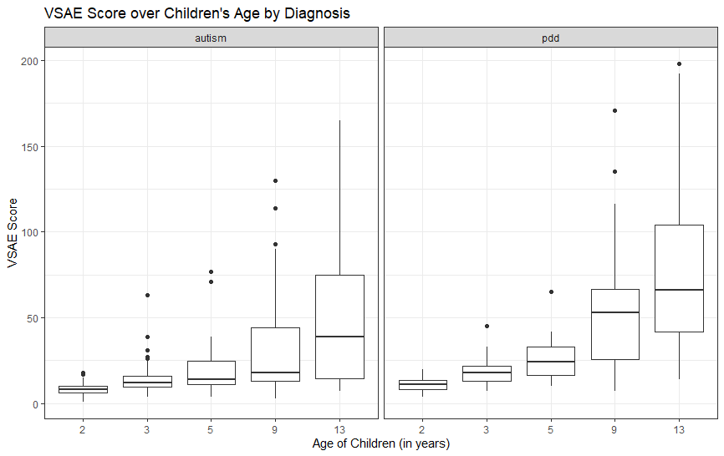

Graph 2: Plot of VSAE over Children’s Age by Diagnosis

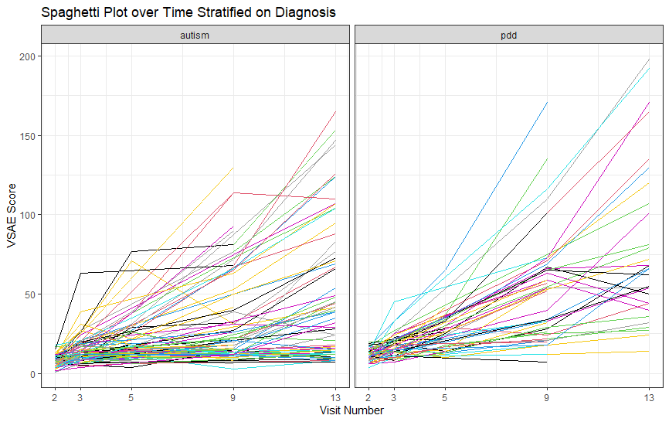
Graph 3: Boxplot of VSAE over Children’s Age by Race

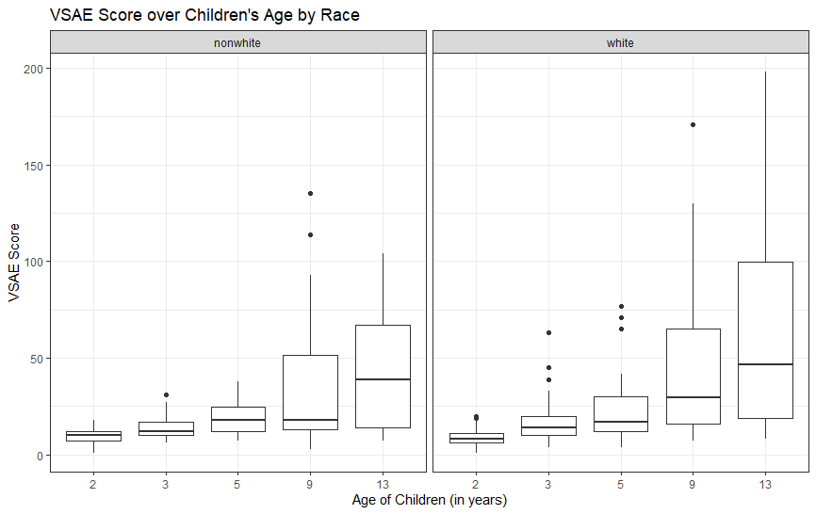

Graph 4: Boxplot of VSAE over Children’s Age by Race

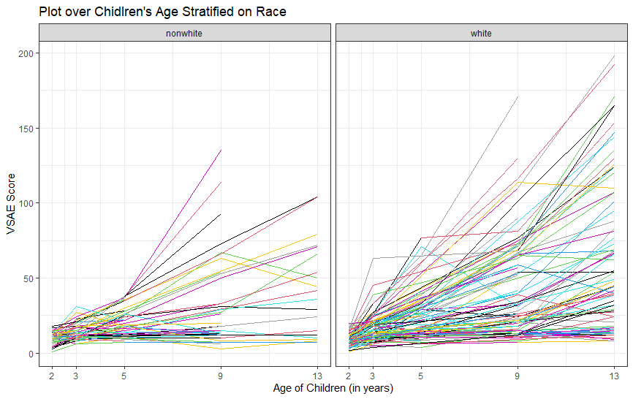

Graph 5: Boxplot of VSAE over Children’s Age by Language Development Score

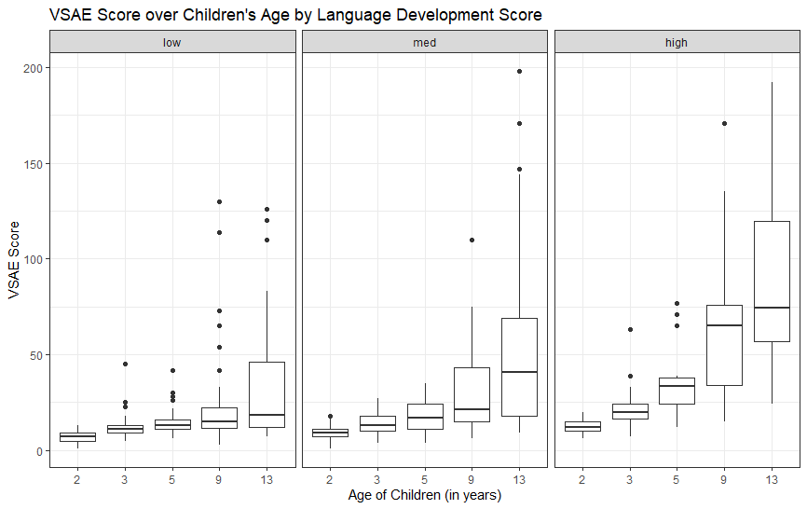

Graph 6: Boxplot of VSAE over Children’s Age by Language Development Score

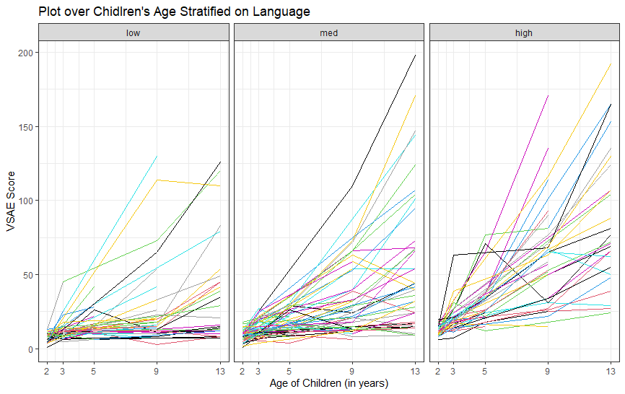

Graph 7: VSAE over Children’s Age at each Visit

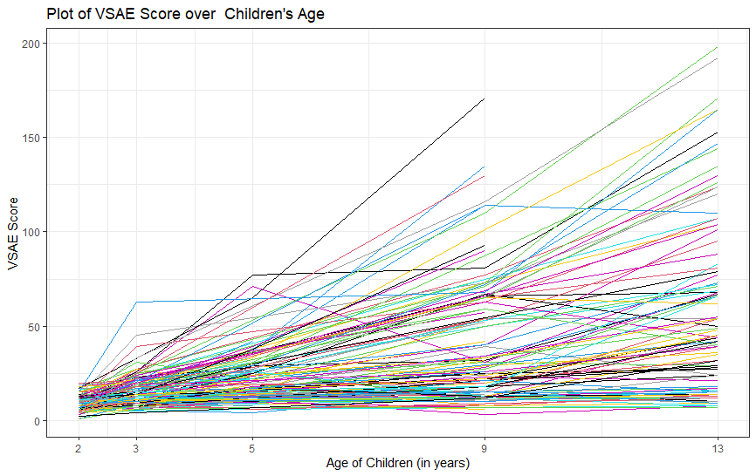

Graph 8: Boxplot of VSAE over Children’s Age at each Visit

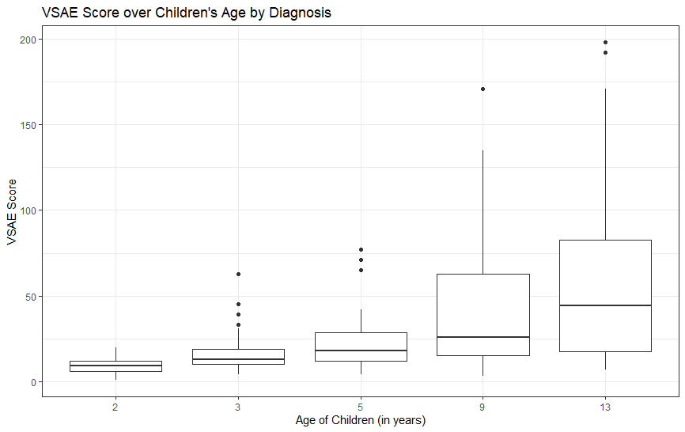
Final Model Section

Table 4: Table for Final Model

Random Effects
Predictor |  | Coefficient (b_{i}) |  | 95% Confidence Interval
Intercept |  | 8.361 |  | 6.76 | 9.864
Age |  | 3.819 |  | 3.313 | 4.273
Fixed Effects
Predictor | Coefficient ($β$_{ij}) | Standard Deviation | P-value | 95% Confidence Interval
Intercept | 5.521 | 2.187 | 0.013* | 1.262 | 9.774
Age | 1.368 | 0.788 | 0.0847 | -0.161 | 2.898
Language=Medium | -3.126 | 2.52 | 0.2038 | -8.123 | 1.69
Language=High | 0.243 | 2.23 | 0.91 | -4.095 | 4.589
Diagnosis=PDD | -2.251 | 2.016 | 0.27 | -6.175 | 1.672
Race=White | -4.645 | 1.99 | 0.02* | -8.52 | -0.774
Age*Language=Medium | 0.328 | 0.805 | 0.6869 | -1.237 | 1.885
Age*Language=High | 3.824 | 0.908 | < 0.0001* | 2.063 | 5.585
Age*Diagnosis=PDD | 1.7 | 0.727 | 0.021* | 0.291 | 3.11
Age*Race=White | 1.809 | 0.718 | 0.013* | 0.417 | 3.201

Table 5: Population and Subject-Specific Final Model

Population Model
$$VSAE_{ij}=5.521+1.368*Age_{ij}+0.243*(Language=Medium_{ij})-3.216(Language={High}_{ij})-$$
$$2.251*\left(Diagnosis=PDD_{ij}\right)-4.645*\left(Race=White_{ij}\right)+$$
$$0.325*\left(Age_{ij}\right)*\left(Language=Medium_{ij}\right)+3.824*\left(Age_{ij}\right)*\left(Language=High_{ij}\right)+$$
$$1.7*(Age_{ij})*(Diagnosis=PDD_{ij})+1.809*\left(Age_{ij}\right)*\left(Race=White_{ij}\right)$$
Subject-Specific Model
$$VSAE_{ij}=13.882+1.368*Age_{ij}+0.243*(Language=Medium_{ij})-3.216(Language={High}_{ij})-$$
$$2.251*\left(Diagnosis=PDD_{ij}\right)-4.645*\left(Race=White_{ij}\right)+$$
$$0.325*\left(Age_{ij}\right)*\left(Language=Medium_{ij}\right)+3.824*\left(Age_{ij}\right)*\left(Language=High_{ij}\right)+$$
$$1.7*\left(Age_{ij}\right)*\left(Diagnosis=PDD_{ij}\right)+1.809*\left(Age_{ij}\right)*\left(Race=White_{ij}\right)+{3.819*(b}_{age_{i}})$$

The original Autism dataset called this variable as bestest2
The original Autism dataset called this variable as sicdegp
The Appendix Graphs and Tables go in order of the Research Questions section.
Percentage is calculated by how many children showed at each individual visit divided by the total number of children enrolled in the study (total sample = 155)
Children’s Age in years
The one patient that did not show on the first visit (the child was approximately 2 years old at this visit) had their Child ID as 60. Patient ID#60 only showed 3 times (She only showed for the 2nd visit at age=3, 4th visit age=9, and 5h visit age=13)
Sequenced Inventory of Communication Development Group (an assessment of expressive language development), formerly known as sicdegp in the original dataset
This is the total number of visits, not the visit number. (i.e., A child that had 4 visits could of skipped visit 2, 3, or 4)
This Percentage column is calculated by how many children showed in total visit divided by the total number of children enrolled in the study (total sample = 155) *Statistically significant at alpha = 0.05

